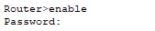
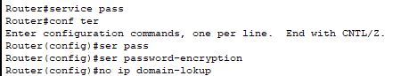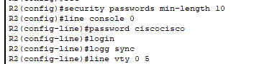
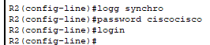
  - Do not timeout/close connection if idle
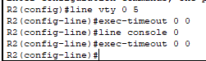
Part 4: Configure G0/0 on R2 (Completion: 29%) 30???
- Access interface G0/0
- Include the description: Link to SW4
- Configure the IPv4 address and subnet mask determined via VLSM
- Configure the IPv6 global unicast address given
- Configure the IPv6 link-local address given
- Activate the interface

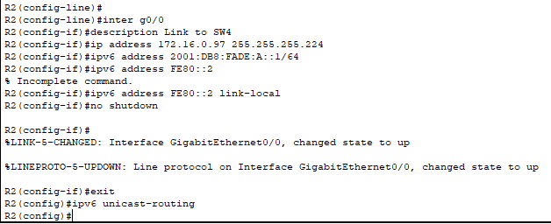
Part 6: Configure R2 for Remote Management Over SSH (Completion: 47%)
- Create a username netadmin with the highest privilege level and encrypted password: ciscocisco
- Configure a domain name: ccna.com
- Generate RSA keys with a modulus of 1024
- Access the first five VTY lines
  - Specify SSH as the transport mechanism to access the VTY lines
  - Require the user to login using the credentials in the local username database.
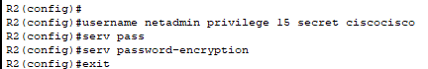
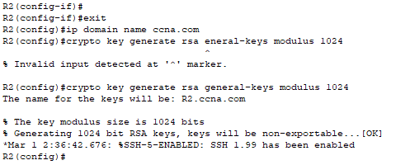
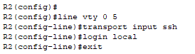
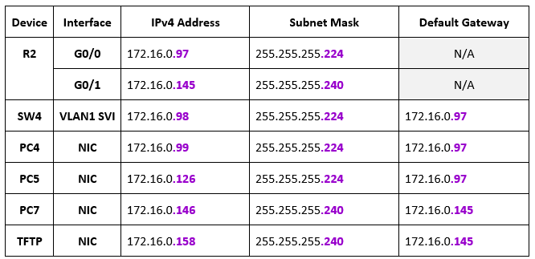
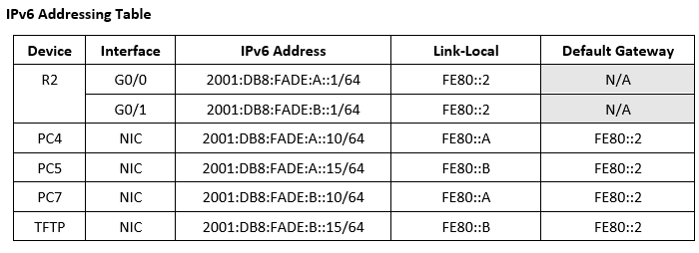

Part 7: Configure SW4 (Completion: 58%)
- Configure the switch hostname: SW4
- Disable DNS lookup
- Configure the default gateway
- Access the VLAN1 SVI (Switch Virtual Interface)
  - Configure the VLAN1 IPv4 address and subnet mask determined via VLSM
  - Activate the SVI
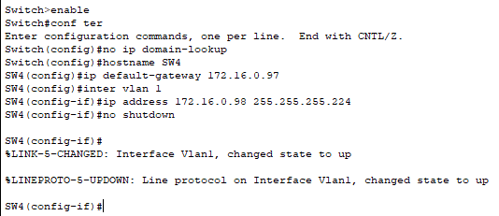

Part 8: Secure Access to SW4 and Save Config (Completion: 69%)
- Access the console line
  - Log messages synchronously
  - Do not timeout/close connection if idle.
  - Configure the console password: ciscocisco
  - Require the user to enter the password to access
- Access all the VTY lines
  - Log messages synchronously
  - Do not timeout/close connection if idle
  - Configure the VTY password: ciscocisco
  - Require the user to enter the password to login

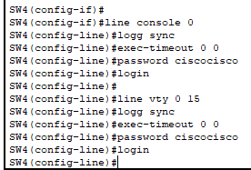
- Save the running configuration to NVRAM
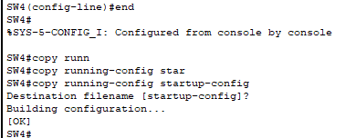

Part 12: Save and Backup the Config on R2 (Completion: 100%)
- Access router R2.
- Save the running configuration to NVRAM
- Copy the running configuration of R2 to the TFTP server using “R2-confg” (w/o quotes) as the name of the destination file.
